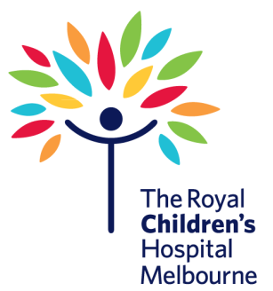

**Training Registration**

Please complete the details below and forward with payment to: [carol.whitehead@rch.org.au](mailto:carol.whitehead@rch.org.au)

One form per registrant:

**Personal Information:**

Name:   
Address:   
Suburb: State: Postcode:   
Phone: Mobile:   
Email:   
School / Children’s Service:   
Course: please tick/cross one

□ 22300VIC Course: First Aid Management of Anaphylaxis - $75.00 + GST

Date of training request: Time

**Registration Fees:** Payment options:

□ Credit card – please ensure all details are completed below

□ please invoice the organisation below

Fill in for credit card payment: □ Mastercard □ Visa  
Card Number: _ _ _ _ / _ _ _ _ / _ _ _ _ / _ _ _ _ Expiry date: _ _ / _ _ Signature:   
Name:   
Organisation:   
Mailing address:   
Suburb: State: Postcode   
Phone: Fax: Email:

Places are limited. Registration is not confirmed until payment is received.  
One week’s notice of cancellation of registration is required or a refund cannot be granted.  
ABN 35 655 720 546 “The Royal Children’s Hospital”

**On payment of this registration, this document becomes a tax invoice**